For this assignment, you will solve problems based on what you have learned in: Object Oriented Programming.
Instructions

- Review the chapters from the book and class notes.
- There are 3 questions in this assignment.
- Assignment submitted after due date will not be evaluated.

Due Date and Time: September 11, 2019, in class.

Submitting this Assignment

You do not have to submit this assignment. When you have completed solving all questions, show them to the Instructor.

Grading Criteria

There are no marks to this assignment.

1. Implement the class StackOfIntegers for the given UMLdiagram. Write a test program that creates the objects of StackOfIntegers and display the result of push, pop and peek operations.
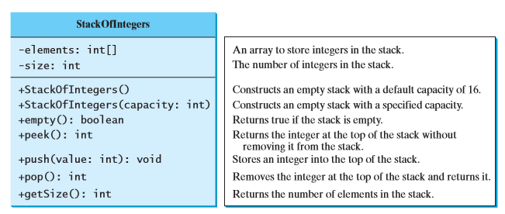

2. Design a class named Time. The class contains:
■ The data fields hour, minute, and second that represent a time.
■ A no-arg constructor that creates a Time object for the current time. (The values of the data fields will represent the current time.)
■ A constructor that constructs a Time object with a specified elapsed time since midnight, January 1, 1970, in milliseconds. (The values of the data fields will represent this time.)
■ A constructor that constructs a Time object with the specified hour, minute, and second.
■ Three getter methods for the data fields hour, minute, and second, respectively.
■ A method named setTime(long elapseTime) that sets a new time for the object using the elapsed time. For example, if the elapsed time is 555550000 milliseconds, the hour is 10, the minute is 19, and the second is 10.

Implement the class. Write a test program that creates two Time objects (using new Time() and new Time(555550000)) and displays their hour, minute, and second in the format hour:minute:second.

3. Define the Circle2D class that contains:
- Two double data fields named x and y that specify the center of the circle with get methods.
- A data field radius with a get method.
- A no-arg constructor that creates a default circle with (0, 0) for (x, y) and 1 for radius.
- A constructor that creates a circle with the specified x, y, and radius.
- A method getArea() that returns the area of the circle.
- A method getPerimeter() that returns the perimeter of the circle.
- A method contains(double x, double y) that returns true if the specified point (x, y) is inside this circle. See Figure (a).
- A method contains(Circle2D circle) that returns true if the specified circle is inside this circle. See Figure (b).
- A method overlaps(Circle2D circle) that returns true if the specified circle overlaps with this circle. See the figure below.

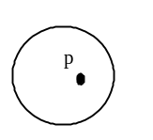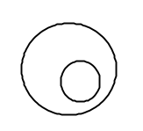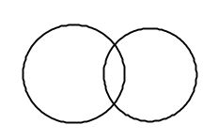

(a) (b) (c)

Figure
(a) A point is inside the circle. (b) A circle is inside another circle. (c) A circle overlaps another circle.

Implement the class. Write a test program that creates a Circle2D object c1 (new Circle2D(2, 2, 5.5)), displays its area and perimeter, and displays the result of c1.contains(3, 3), c1.contains(new Circle2D(4, 5, 10.5)), and c1.overlaps(new Circle2D(3, 5, 2.3)).

public class NGLA61 {
public static void main(String[] args) {
Circle2D c1 = new Circle2D(2, 2, 5.5);
System.out.println("Area is " + c1.getArea());
System.out.println("Perimeter is " + c1.getPerimeter());
System.out.println(c1.contains(3, 3));
System.out.println(c1.contains(new Circle2D(4, 5, 10.5)));
System.out.println(c1.overlaps(new Circle2D(3, 5, 2.3)));
}
}

class Circle2D {
// Implement your class here
}

